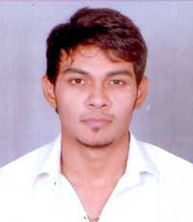
Trainer Profile

NAME : Mr. Nitin Patel

NATIONALITY : Indian

QUALIFICATIONS : B.E (Electrical)

Mr. Nitin Patel is currently a Sr. Engineer (Technical Services) in Maruti Centre For Excellence, Maruti Suzuki India Ltd at Manesar. He has About 7+ of working experience in Manufacturing and Power generation industries. His has a Degree in Electrical / Pursue Mtech in Power systems. His exposure in Power Generation, Transmission, Distribution and switchgears maintenance has been nearly 4 years and in Automation Field has been nearly 3 years.
Most of the mistake that he had notice Is that of a poor understanding of Basic Electrical /Automation practices and its impact to daily manufacturing environment. He has conducted numerous training on Electrical and Automation Modules for companies.
OBJECTIVE:
To strive for excellence to work in such an environment that will enhance my Knowledge and Career where I can perform my Talent on Training Skills according to my strong Caliber and Efficiency and to fulfill the required gap for any individuals or group according to Industry needs and giving some valuable change in the Industrial Field and the Society in general.
PROFICIENT IN TRAINING:
Basic PLC Programming, Advance PLC Programming, SCADA Programming and Designing, HMI Programming and Designing, AC/DC Drive , AC/DC Motor commissioning and trouble shooting, Power Systems, Maintenance of Switchgears, Power quality and Energy Management, Industrial Automation ( Low Cost Automation ).

